PARENT HANDOUT FOR
FRENCH LANGUAGE REMOTE LEARNING PROJECTS
This document is an adaptation of a guide created for French language teachers. It includes English translations of instructions for parents and caregivers whose children attend French language programs but who do not speak French themselves.

Parents/caregivers may access additional resources at:
- My Learning at Home (www.edu.gov.mb.ca/k12/mylearning)
- My Child in School (www.edu.gov.mb.ca/k12/mychild/index.html)

PROJECT OVERVIEW
Grade: | Maternelle
Subject: | Science, Français, Maths
Big Idea: | Vocabulary, the different uses of trees, and the basic parts of trees
Title: | LES ARBRES (1re partie) – Immersion française
Cluster: | Les arbres
Duration: | 2 to 4 weeks (varies according to the number of times activities are repeated)
Materials: | Printed copies of annex documents, paper, pencils, coloured pencils, wax crayons, or felt markers., pencil sharpener, scissors, paper clips or tape

Developed by: | Theressa Kielhorn François

LEARNING EXPERIENCES
Question 1: What are the basic parts of trees?
Student and caregiver instructions for remote learning experiences:
NB: You are encouraged to repeat these activities several times and on different days. Doing so will help your child to master targeted skills. You are also encouraged to take breaks as often as needed.

Activating Knowledge Through Movement (10+ minutes on multiple occasions)
- Watch the following YouTube video: L’arbre est dans ses feuilles by Denise Anctil à https://youtu.be/BznguR2aITQ
- Make the gestures and try to sing along with the music. Below are pictures of the gestures and words.
- Challenge: Can you teach this dance to a parent? A grandparent? A cousin? A dog? A stuffed animal?

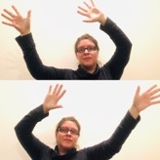 | 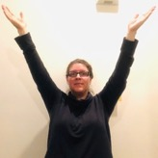 | 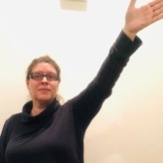 | 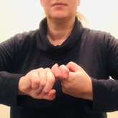 | 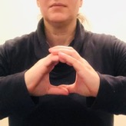
L’arbre est dans ses feuilles…  The tree is in its leaves | ARBRE  tree | BRANCHE  branch | NŒUD  knot | TROU  hole
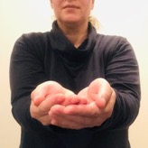 | 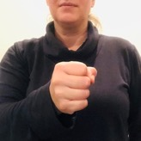 | 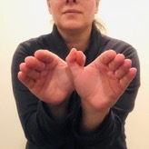 | 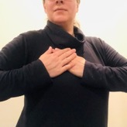 | 
NID  nest | OEUF  egg | OISEAU  bird | COEUR  heart | AMOUR  love

Online Reading – Tu fais un travail important (15 minutes+)
- This online book is available at https://www.idello.org/fr/ressource/22999-Tu-Fais-Un-Travail-Important-Le-Pluriel-Des-Noms?navcontext=32413
- You will need a free Idéllo account to read this book. If you are a registered homeschooling family, you can also access this book through the DREF French language library. Parents are strongly encouraged to create a free Idéllo account to access even more great French language digital books, videos, and other resources.
- Questions to answer after reading the book:
  - What does the main character do in this story?
  - What happens at the beginning of this story? In the middle? At the end?
  - Have you already seen characters and objects from the story in real life? When and where?
  - Do you like this story? Why or why not?

Activating Knowledge Through Art (15-60+ minutes)
- Watch this video and draw along with the little white rabbit: Didou dessine-moi un arbre https://youtu.be/xtgZ9-DygN8 (15 minutes)
- Draw a forest using only simple shapes (rectangle, triangle, square, circle). Here are some examples of drawings:

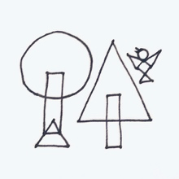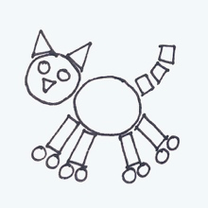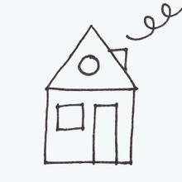

- Look at your forest drawing and answer the following questions:
  - What kinds of trees are in your forest?
  - Are there animals in your forest?
  - How many trees did you draw?
  - Count the circles, triangles, rectangles, and squares in your drawing. How many are there of each shape?

The Hunt for 3D Shapes (15+ minutes on multiple occasions)
- At home or outside, look for the following 3D shapes. Examine the trees you see closely. Are there any trees that look like these shapes? Are there any other objects that look like these shapes?
- Draw or take pictures of the best examples of shapes you found in the trees.
- Share your results with the class!

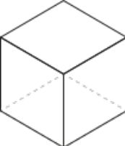 | 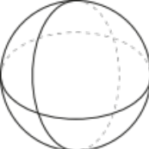 | 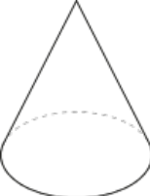 | 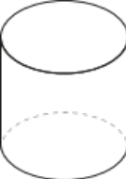 | 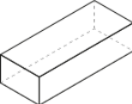  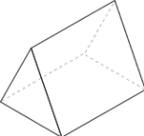 | 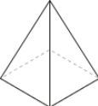  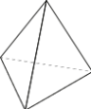
CUBE | SPHÈRE | CÔNE | CYLINDRE | PRISME | PYRAMIDE
Image source: Clipart.com

Making Bingo Cards (15+ minutes over a few sessions)
NB: Some students will be very tired after only completing one or two cards. Students are not expected to complete all the cards in one go. It is better to spread this learning experience over several sessions based on your child’s abilities and needs. Repeating the steps also helps to reinforce the skills at each session.
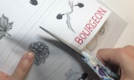  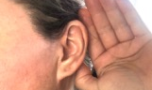  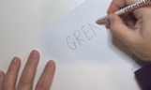  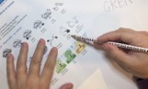  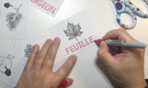  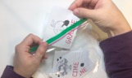 | - Have the student cut out the vocabulary cards. (Annexe D : Cartes lexicales Bingo)  - Caregivers are encouraged to slowly pronounce each term for the student. A complete list of terms (lexicon) is included in this document. (Annexe A : Lexique)  - If you do not feel comfortable pronouncing the French terms, please download the slideshow presentation that goes along with this project (posted on the provincial Remote Learning Repository website). Play the presentation and click on each word to hear an audio file of the term.  - Students should listen closely to the sounds of each word.  - Ask the student “Can you hear the first letter sound?" Have them write the letter on a piece of scrap paper. Let’s try the next sound! Have the student attempt to write the letters they think go with each sound.  NB: Caregivers may spell out the word only if the student is frustrated or they have not yet studied the letters and letter combinations (graphemes) associated with the sound.  - Have the student compare their spelling with that of the lexicon. (Annexe A : Lexique) Ask "How many letters did you guess? Well done!”  - The student may now use the lexicon to correctly write the term on the vocabulary card. Ready for another word? Let’s go!  - If playing in a classroom, have the student write their initials on the back of each vocabulary card. This prevents them from mixing up their cards with those of their classmates.  - Keep the cards in a small bag or envelope for playing Bingo online or to consult later.

Instructions for Playing Bingo (15-30+ minutes on multiple occasions)
NB: Students can play Bingo even if they haven’t yet written the words on their Bingo cards. The cards should be cut up in advance, however.
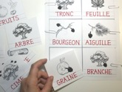  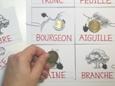 | - Students prepare their Bingo cards by selecting and placing 6 vocabulary cards on the provided Bingo card. Do not glue down the vocabulary cards – we’ll be reusing them!  - You may use coins, rocks, building blocks as Bingo tokens – or something else!  - Encourage the student to use French expressions during gameplay. Some examples include « Je l’ai! » (I’ve got it!), « Je ne l’ai pas. » (I don’t have it.), « Je vais gagner! » (I’m going to win!), « J’ai 4 jetons! » (I have 4 tokens!), etc.  - Encourage your child to repeat the vocabulary terms used during gameplay. Your child may be selected to call out words for the next Bingo game!

Question 2: What can we learn using trees?
Student and caregiver instructions for remote learning experiences:
NB: You are encouraged to repeat these activities several times and on different days. Doing so will help your child to master targeted skills. You are also encouraged to take breaks as often as needed.

Writing with Trees (15+ minutes on multiple occasions)
NB: If you do not have access to sticks and leaves, you may use household items such as utensils, toothpicks, or the like. Draw or take photos of your letters to share with the class!
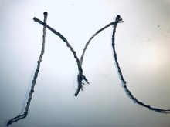  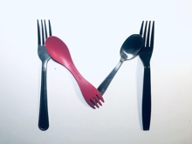 | Two to four people can play this game.  - Together, the players collect sticks and leaves of different sizes.  - The first player makes a letter sound, or phoneme. (ex: « mmmmmm »).  - The other player tries writing the appropriate letter using sticks and leaves (the letter “M” in this case).  - If the answer is correct, the first player must think of a word beginning with that sound, such as “mom”.  - The players switch places and continue playing.

The importance of phonological awareness:
A fundamental reading skill is the ability to decode text. Decoding means translating letters and letter combinations (graphemes) into sounds. The mirror image of decoding is the ability of students to pick out sounds (phonemes) from the words they hear and associate them with letters. In Kindergarten, phonological awareness also involves noticing rhymes and alliterations (words beginning with the same sounds) and breaking up sentences into individual words. Phonological awareness exercises concretely demonstrate the links between spoken and written language.

Counting, comparing, categorizing, and creating patterns using trees (15+ minutes on multiple occasions)
NB: If you do not have access to sticks and leaves, you may use household items such as utensils, containers, or the like. Draw or take photos of your letters to share with the class!
Can you compare and sort branches and leaves according to:
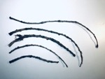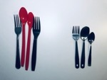 | - Length or width? (“Which branch is the longest? Which leaf is widest?”)  - Thickness or weight? (“Which branch weighs the most?”)  - Colour or texture?  - Other criteria?

Can you create groups of branches and leaves according to:
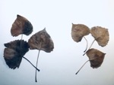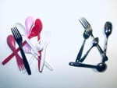 | - Colour (“Can you put leaves of the same colour together?”)  - Size or shape?  - Texture or material?  - Other criteria?

Can you create patterns using branches and leaves?
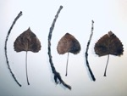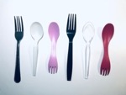 | - Have your child complete Annexe C : Prolonger et créer des régularités in preparation for this learning experience or to enrich it afterwards.

Can you count branches and leaves and arrange them in groupings?

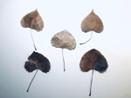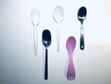 | - Have your child complete Annexe B : Jeu de mémoire in preparation for this learning experience or to enrich it afterwards.

Question 3: How do people and animals use trees?
Student and caregiver instructions for remote learning experiences:
NB: You are encouraged to repeat these activities several times and on different days. Doing so will help your child to master targeted skills. You are also encouraged to take breaks as often as needed.

Field notebook – The different uses of trees (15-30 minutes on at least 3 occasions)
NB: If the student cannot go outside to make direct observations, or there are no trees visible from home, they may instead survey family members and friends to collect information.
- Outside or at a window, observe a tree for some time.

- Draw what you see in your field notebook (Annexe E : Carnet de recherches : L’utilité des arbres). You can add more pages if you need more space to record your observations. Organise your pages according to the field notebook:

Page 1: How do animals use trees?
  - What do different animals do in trees?
Page 2: How do humans use trees?
  - Can you find objects made from trees in your home or around you?
Page 3: How I like to use trees.
  - Do I use objects made from trees to play or to study?

- Can you label your drawing or add written notes to it? You don’t need to spell words perfectly right now – just do your best! NB: Students may use invented spelling to label their drawings. Words are neither copied, nor corrected (for the moment) *.

* The importance of invented spelling
Invented spelling reveals a child’s understanding of the alphabetic principle – the link between letters and their sounds. A student who writes "I LIK SOKR" (I like soccer) is demonstrating that he or she hears the sounds (phonemes) in words and associates them with the appropriate letters. Once a child has mastered the alphabetic principle, he or she is ready to study traditional, or “correct” spelling.

ANNEXES (Matériel d'appui en format imprimable)
Le vocabulaire, l’utilité, et les principales parties des arbres

Maternelle – Sciences de la nature – Les arbres

A : Table des matières et lexique

Table des MATIÈRES :
- Annexe A : Lexique Maternelle -
- Annexe B : Jeu de mémoire (Reconnaissance globale nº 1)
- Annexe C : Prolonger et créer des régularités
- Annexe D : Cartes lexicales Bingo
- Annexe E : Carnet de recherches : L’utilité des arbres

Lexique Maternelle - Les arbres
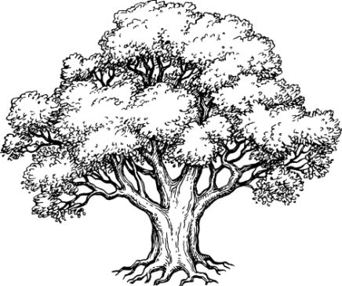 | 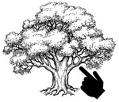 | 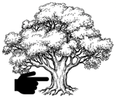 | 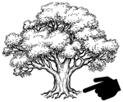 | 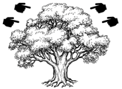 | 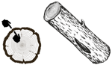
ARBRE  l’arbre | BRANCHE  la branche | TRONC  le tronc | RACINE  la racine | CIME  la cime | ÉCORCE  l’écorce
 | 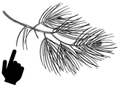 |  | 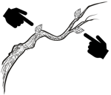 | 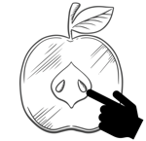 | 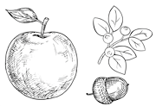
FEUILLE  la feuille | AIGUILLE  l’aiguille | la COCOTTE  ou  la POMME DE PIN | BOURGEON  le bourgeon | GRAINE  la graine | FRUIT  le fruit  (pomme, baie, gland, noix)
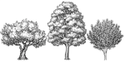 | 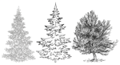 | 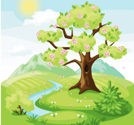 |  |  | 
FEUILLUS  les feuillus | CONIFÈRES  les conifères | PRINTEMPS  le printemps | ÉTÉ  l’été | AUTOMNE  l’automne | HIVER  l’hiver
Image source: Clipart.com

Annexe B : Jeu de mémoire (Reconnaissance globale nº 1)
Source : https://www.edu.gov.mb.ca/m12/frpub/ped/ma/sac/0-mat/index.html

Jeu de mémoire

(Reconnaissance globale nº 1)

Matériel : Un jeu qui contient 24 cartes

Joueurs : Deux ou trois

Règles du jeu : Mélanger les cartes, puis les placer face contre table. Tour à tour, les joueurs retournent deux cartes à la fois. Si les deux cartes représentent le même nombre, le joueur qui les a retournées garde ces cartes, puis en retourne deux autres. Si les deux cartes qui viennent d’être retournées ne représentent pas le même nombre, on les replace face contre table et c’est au tour du prochain joueur à retourner deux autres cartes. Le jeu continue ainsi jusqu’à ce que toutes les cartes aient été regroupées en paires.

Variantes : Placer les 24 cartes de façon à bien voir le nombre représenté sur chacune d’elles (face vers le haut).
Former des paires de cartes qui représentent le même nombre.

Voici les 24 cartes que contient ce jeu :



4

1




5

2





6

3

Le Bureau de l’éducation française autorise la reproduction totale ou partielle de ce document à des fins éducationnelles non commerciales à condition que la source soit mentionnée. Nous nous sommes efforcés d’indiquer comme il se doit les sources originales et de respecter la Loi sur le droit d’auteur. Les omissions et les erreurs devraient être signalées à Éducation et Jeunesse Manitoba pour correction.

Annexe B : Jeu de mémoire (Reconnaissance globale nº 1)

Source : https://www.edu.gov.mb.ca/m12/frpub/ped/ma/sac/0-mat/index.html

Note à l’intention des parents :
Le jeu de mémoire ci-joint fait appel à la reconnaissance globale.

La reconnaissance globale, c’est de « voir instantanément combien il y en a... »

Par exemple, un enfant pourrait, en utilisant la reconnaissance globale, dire combien de points on retrouve dans chacune de ces figures, et ce, sans avoir à compter les points.

La reconnaissance globale aide l’enfant à se former des images mentales du nombre et à saisir qu’un nombre peut être représenté de plusieurs façons :

Six, c’est mais c’est aussi ou encore

Dans le dernier exemple, un enfant dira qu’il y a six points parce qu’il voit « cinq avec un ». C’est le début de l’addition, tant du point de vue du sens que de celui du calcul.

JEU DE MÉMOIRE (reconnaissance globale nº 1)

Reconnaissance globale

Addition

Annexe B : Jeu de mémoire (Reconnaissance globale nº 1)
Source : https://www.edu.gov.mb.ca/m12/frpub/ped/ma/sac/0-mat/index.html
 |  | 1
 |  | 2 | 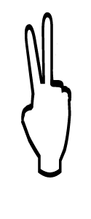
 |  | 3 | 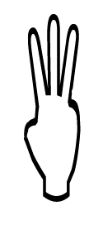

Annexe B : Jeu de mémoire (Reconnaissance globale nº 1)
Source : https://www.edu.gov.mb.ca/m12/frpub/ped/ma/sac/0-mat/index.html
 |  | 4 | 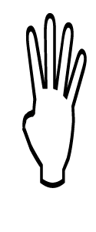
 |  | 5 | 
 |  | 6 | 

Annexe C : Prolonger les régularités |  |  | Nom : _____________________________

Prolonge les régularités en ajoutant des formes aux colonnes. Défi : Crée une version gestuelle de chaque régularité.
1. | 2. | 3. | 4.  DÉFI! | 5.  DÉFI! | 6.  DÉFI!

Annexe C : Créer des régularités | Nom : _____________________________

Crée une nouvelle régularité sur chaque feuille. Défi additionnel : Crée une version gestuelle de chaque régularité.

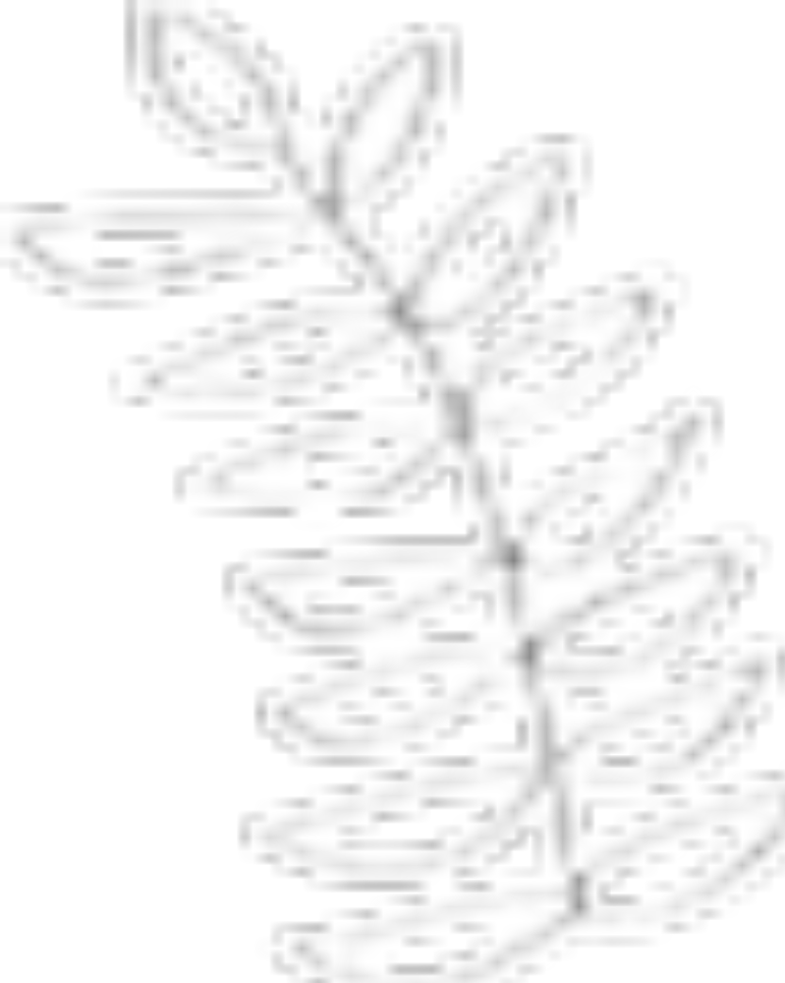
Image source: Clipart.com

Annexe D : Cartes lexicales Bingo – Les arbres (image source: Clipart.com)
  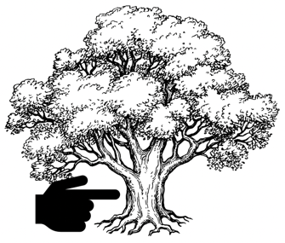
  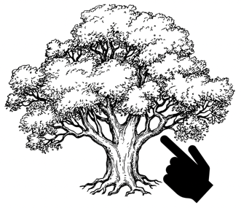
  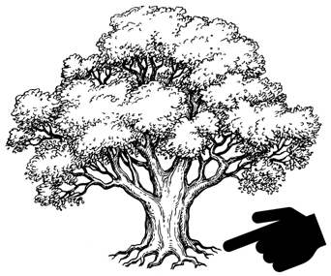
  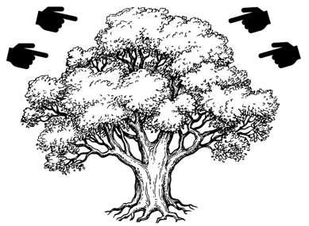
  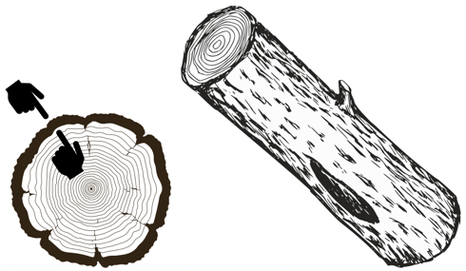

Annexe D : Cartes lexicales Bingo – Les arbres (image source: Clipart.com)
  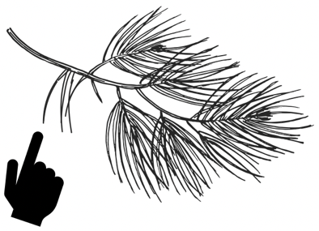
  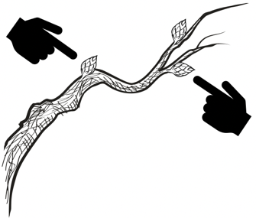
  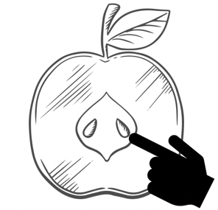
  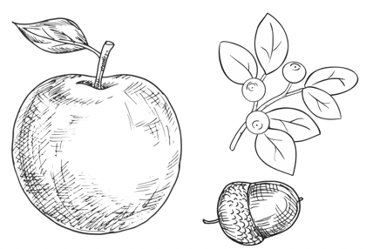

Annexe D : Cartes lexicales Bingo – Les arbres (image source: Clipart.com)
  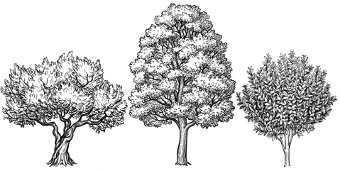
  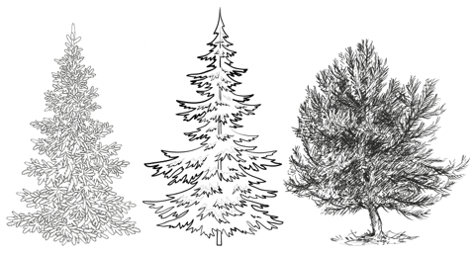
  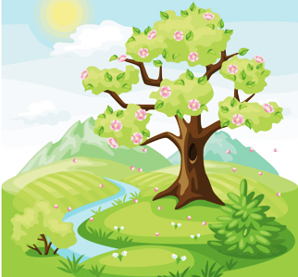
  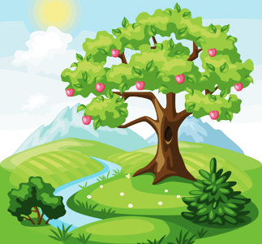
  
  

Carte Bingo |  | Nom : _____________________________
1  Place une carte ici.  Ne pas coller! |  |  | 2  Place une carte ici.  Ne pas coller!
3  Place une carte ici.  Ne pas coller! |  |  | 4  Place une carte ici.  Ne pas coller!
5  Place une carte ici.  Ne pas coller! |  |  | 6  Place une carte ici.  Ne pas coller!

Annexe E : Carnet de recherche | Nom : _____________________________

Comment les animaux utilisent-ils les arbres?
Dessine tes observations et tes recherches ici. Peux-tu libeller ton dessin? Tu peux attacher d’autres feuilles de papier au carnet pour l’augmenter :
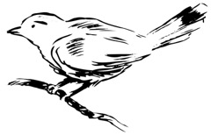
Image source: Clipart.com

Annexe E : Carnet de recherche | Nom : _____________________________

Comment les humains utilisent-ils les arbres?
Dessine tes observations et tes recherches ici. Peux-tu libeller ton dessin? Tu peux attacher d’autres feuilles de papier au carnet pour l’augmenter :
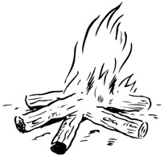
Image source: Clipart.com

Annexe E : Carnet de recherche | Nom : _____________________________

Comment moi, j’utilise les arbres.
Dessine tes observations et tes recherches ici. Tu peux attacher d’autres feuilles de papier au carnet pour l’augmenter :
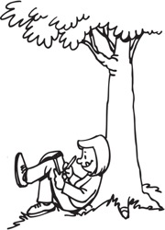
Image source: Clipart.com

